**S-100 – Part 2**

**Management of Registers**

Summary of Substantive Changes in Edition 5.2.0

|  |  |
| --- | --- |
| Change Summary | Clauses Effected |
| **Part 2 – Management of Registers** | |
|  |  |
|  |  |

Contents

2-1 Scope 1

2-2 Conformance 1

2-3 Normative references 1

2-4 General concepts 2

2-4.1 Registry 2

2-4.1.1 Registry Owner 2

2-4.1.2 Registry Manager 2

2-4.2 Register 2

2-4.2.1 Registers within the IHO Geospatial Information (GI) Registry 2

2-5 Roles and responsibilities in the management of Registers 2

2-5.1 Register Owner 2

2-5.2 Register Manager 3

2-5.3 Register User 3

2-5.4 Domain Control Body 3

2-5.5 Executive Control Body 3

2-5.6 Submitting Organizations 3

2-5.6.1 Eligible Submitting Organizations 3

2-5.7 Processing of Proposals 3

2-5.7.1 Addition of registered items 4

2-5.7.2 Clarification of registered items 4

2-5.7.3 Supersession of registered items 4

2-5.7.4 Retirement of registered items 4

2-6 The Register Manager shall 4

2-6.1 Proposal legitimacy 4

2-7 Proposal process 5

2-7.1 Approval process 6

2-7.1.1 Withdrawal of proposals 8

2-7.1.2 Appeals 8

2-7.2 List of Submitting Organizations 8

2-7.3 Publication 8

2-7.4 Integrity 9

2-8 Register Schema 9

2-8.1 Introduction 9

2-8.2 S100_RE_Register 11

2-8.3 S100_RE_RegisterItem 11

2-8.4 S100_RE_ItemStatus 13

2-8.5 S100_RE_ReferenceSource 13

2-8.6 S100_RE_SimilarityToSource 14

2-8.7 S100_RE_Reference 14

2-8.8 S100_RE_ManagementInfo 15

2-8.9 S100_RE_ProposalType 15

2-8.10 S100_RE_ProposalStatus 16

Page intentionally left blank

# Scope

This Part of S-100 specifies procedures to be followed in maintaining and publishing Registers of unique, unambiguous and permanent identifiers that are assigned to items of geographic, hydrographic and metadata information. In order to accomplish this purpose, this Part describes the roles and responsibilities for the management of a Registry and its Registers. Specific administrative details of the IHO Geospatial Information (GI) Registry and its Registers is documented in IHO Publication S-99.

# Conformance

This profile conforms to level 2 of ISO 19106:2004. The following is a brief description of the specializations and generalizations where the profile differs from ISO 19135:2005.

1. S100_RE_Register constrains the use of the attribute alternativeLanguages.
2. S100_RE_RegisterItem constrains the use of the attributes fieldOfApplication and alternativeExpression.
3. S100_RE_RegisterItem renames the attribute description to remarks.
4. S100_RE_ManagementInfo is a new class which amalgamates the classes RE_DecisionStatus, S100_RE_ProposalType, S100_RE_SubmittingOrganization, S100_RE_ItemStatus and RE_Disposition.
5. S100_RE_ProposalType is a new class which amalgamates the ISO 19135 classes RE_AdditionInformation, RE_ClarificationInformation, RE_AmendmentInformation and RE_AmendmentType.

# Normative references

ISO 19126:2009, *Geographic Information – Feature concept dictionaries and registers*

ISO 19135:2005, *Geographic Information – Procedures for registration of items of geographic information*

ISO 8601:2004, *Data elements and interchange formats - Information interchange – Representation of dates and times*

IHO S-99, *Operational Procedures for the Organization and Management of the IHO Geospatial Information Registry*

# General concepts

## Registry

A Registry is the information system on which a Register or series of Registers is maintained.

### Registry Owner

A Registry Owner has the authority to host the Registers and establish the policy for access. The Registry Owner decides whether a proposed Register shall be hosted on the Registry.

### Registry Manager

The Registry Manager is responsible for the day-to-day operation of the Registry. This includes:

1. providing Registry access for Register Managers, Control Bodies, and Register Users;
2. ensuring that information about items in the Registers is readily available to users in relation to those items that have the status of valid, invalid, clarified, superseded, retired or processing;
3. accepting proposals and forwarding them to all Register Managers; and
4. managing the resolution of persistent URI identifiers to appropriate resources, but only if resolution services are provided on a Registry server.

## Register

A Register is simply a managed list. It is easier to maintain than a fixed document, because new items can be added as needed to the Register; and existing items in the Register can be clarified, superseded or retired. Each Register item has one or more dates associated with it that indicate when changes in its status occurred. This means that a Product Specification, defined at a given date, may reference an item in the Register at a specific point in time.

### Registers within the IHO Geospatial Information (GI) Registry

The following Registers have been implemented within the IHO Geospatial Information (GI) Registry structure. A full description of these Registers is included in the accompanying references:

* Concept Register (S-100 Part 2a);
* Data Dictionary Register (S-100 Part 2a);
* Portrayal Register (S-100 Part 2b);
* Metadata Register (not currently described - to be included in a future Edition of S-100);
* Product Specification Register (not currently described - to be included in a future Edition of S-100); and
* Producer Code Register (not currently described - to be included in a future Edition of S-100).

A description of the operational and management procedures for the IHO GI Registry, expanding further on the general concepts described in the following clauses, is included in IHO Publication S-99 – *Operational Procedures for the Organization and Management of the IHO Geospatial Information (GI) Registry*.

# Roles and responsibilities in the management of Registers

## Register Owner

The Register Owner is an organization that:

1. establishes one or more Registers within a Registry;
2. has primary responsibility for the management, dissemination, and intellectual content of those Registers;
3. may appoint another organization to serve as the Register Manager; and
4. shall establish a procedure to process proposals and appeals made by Submitting Organizations.

## Register Manager

The Register Manager is responsible for the administration of a Register. This includes:

1. coordinating with other Register Managers, Submitting Organizations, the related Control Body, Register Owner and the Registry Manager;
2. maintaining items within the Register;
3. maintain and publish a List of Submitting Organizations;
4. distributing an information package containing a description of the Register and how to submit proposals; and
5. providing periodic reports to the Register Owner and/or the Control Body. Each report shall describe the proposals received and the decisions taken since the last report. The interval between those reports must not exceed 12 months.

A Register Manager may manage multiple Registers.

## Register User

A Register User is any person or organization interested in accessing or determining the content of a Register.

## Domain Control Body

The Domain Control Body (DCB) for a Register is a group of technical experts appointed by a Register Owner to decide on the acceptability of proposals for changes to the content of a Register. The group must comprise experts in the related field that makes up the contents of the Register. As such, the DCB consists of at least one representative from each of the Domains contributing to the content of the Register.

## Executive Control Body

The Executive Control Body (ECB) must consist of a representative of each of the Domains within the Register. The ECB will monitor and advise the Register Manager(s) and act as arbiters for any decisions or disputes in the Register process. In the event that a resolution cannot be achieved, the ECB may request a decision from the IHO Hydrographic Services and Standards Committee (HSSC).

## Submitting Organizations

### Eligible Submitting Organizations

A Submitting Organization is an organization that is qualified under criteria determined by the Register Owner to propose changes to the content of a Register. The Register Manager must determine whether a Submitting Organization is qualified in accordance with the criteria established by the Register Owner. An approved Submitting Organization shall have at least one representative appointed to submit proposals to the Register on its behalf (multiple representatives of a Submitting Organization may be appointed in consultation with the Register Manager).

## Processing of Proposals

Submitting Organizations may submit requests for addition, clarification, supersession, and retirement of registered items.

### Addition of registered items

Addition is the insertion into a Register of a new item that describes a concept not adequately described by a valid or processing item already in the Register.

### Clarification of registered items

Clarifications correct errors in spelling, punctuation, grammar or improvements to content or wording. A clarification shall not cause any substantive semantic change to a registered item. The three characteristics that may be clarified are definition, other references, and remarks.

### Supersession of registered items

Supersession of an item means any proposal that would result in a substantive semantic change to an existing valid item, such as a change to the name of an item or its camelCase identifier; or a change in the portrayal of an item in the Portrayal Register. Supersession shall be accomplished by including one or more new items in the Register with new identifiers and a more recent date. The original item shall remain in the Register but must include the date at which it was superseded, and a reference to the items that superseded it.

### Retirement of registered items

Retirement shall be affected by leaving the item in the Register; marking it retired; and including the date of retirement.

# The Register Manager shall

1. Receive proposals from Submitting Organization representatives;
2. Review proposals for completeness;
3. Return proposals to the Submitting Organization representative if incomplete;
4. Check within the Register for similar proposals; and if similar, the Register Manager shall contact the Submitting Organization representative;
5. Coordinate proposals with other Register Managers within two calendar weeks from the date received;
6. Generate a proposal management record, with the status set to ‘transferred’; and
7. Initiate the approval process.

## Proposal legitimacy

The Register Manager shall use the following criteria to determine if the proposal is complete and reject the proposal if:

1. The submitter is not a qualified Submitting Organization representative;
2. The proposed item does not belong to an item class assigned to this Register Manager;
3. The proposed item does not fall within the scope of the Register; or
4. The proposed item has already been proposed.

# Proposal process

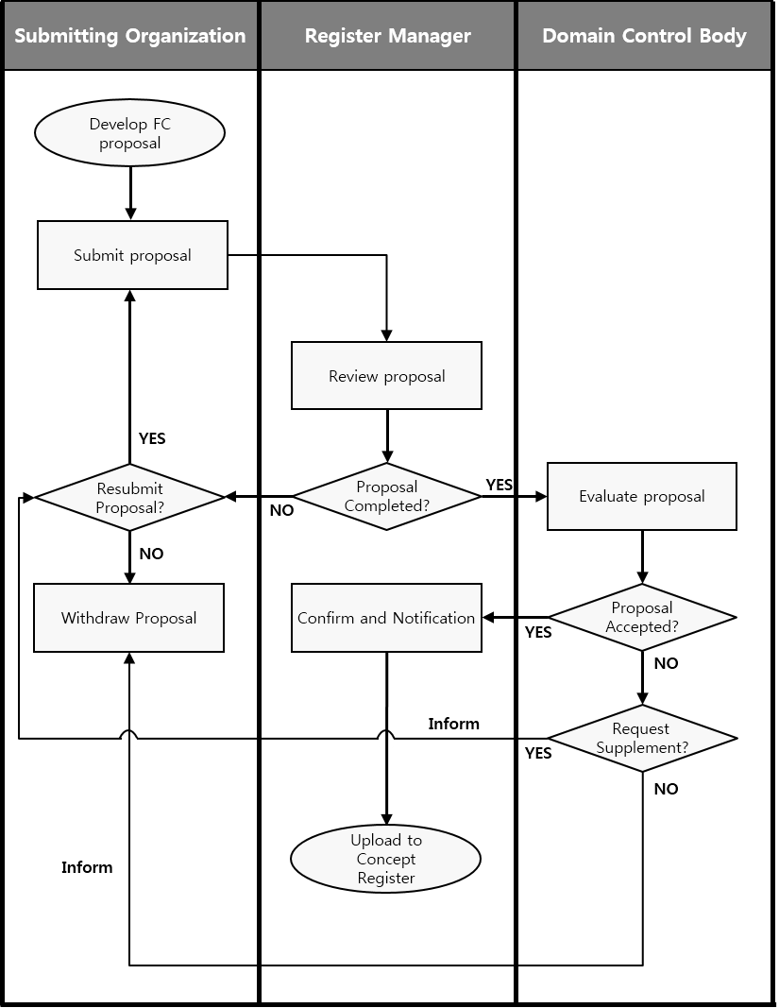

Figure 2-1 – Proposal process – Concept Register

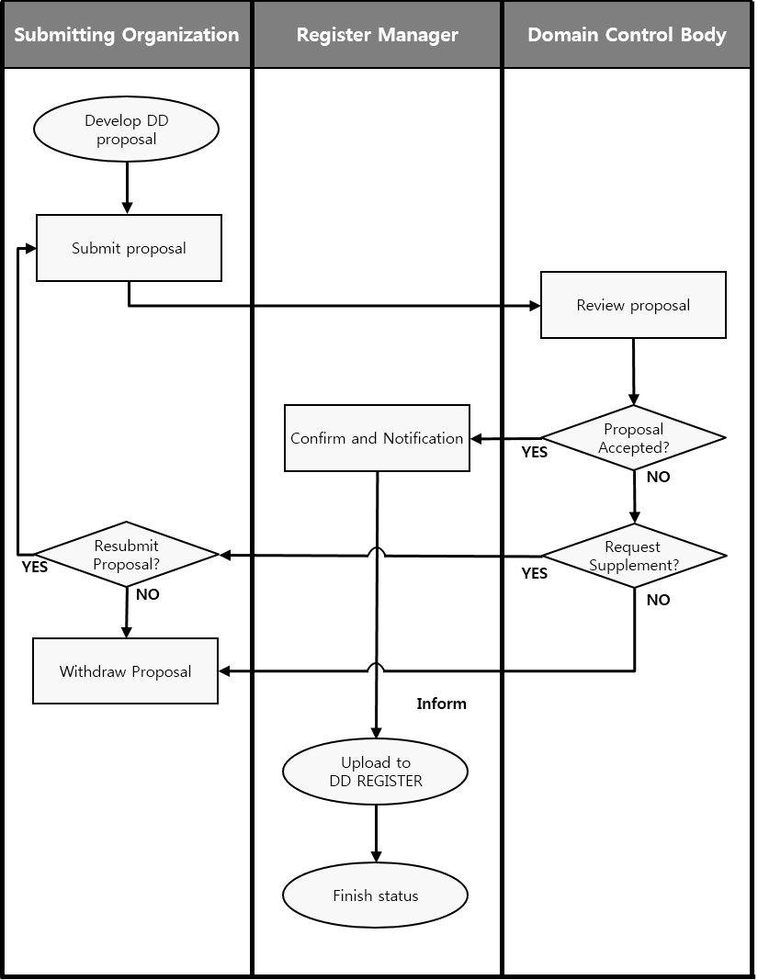

Figure 2-2 – Proposal process – Data Dictionary Register

## Approval process

The process for determining the acceptability of proposals is illustrated in Figures 2-1 and 2-2 above. It must be completed within a time period specified by the Register Owner, in accordance with S-99.

The Register Manager shall ensure the following:

1. If the proposal is for clarification or retirement of a Register item, set the *itemStatus* of the item to ‘processing'; and forward the proposal to the Register Domain Control Body; or
2. If the proposal is for registration of a new item or supersession of an existing Register item:
   1. Assign an *itemIdentifier* to the new or superseding item;
   2. Set the *itemStatus* of the item to ‘processing', and
   3. forward the proposal to the Register Domain Control Body.

The Register Domain Control Body shall:

1. Decide to accept the proposal without change; to accept the proposal subject to changes negotiated with the Submitting Organization; or not to accept the proposal. Criteria for not accepting a proposal include:
   1. The specification of the item is incomplete or incomprehensible;
   2. An identical or very similar item already exists in the Register or in another Register of the Registry;
   3. The proposed item does not belong to an item class included in the Register;
   4. The proposed item does not fall within the scope of this Register; or
   5. The justification for the proposal is inadequate.
2. Inform the Register Manager of the decision, and the rationale for the decision, within a time limit specified by the Register Owner, in accordance with S-99.

The Register Manager shall:

1. Serve as the point of contact if there is a need for negotiations between the Submitting Organization and the Register Domain Control Body regarding changes to the proposal that are specified by the Domain Control Body as a condition of acceptance; and
2. Inform the Submitting Organization representative of the results of processing the proposal.

If the decision of the Register Domain Control Body is positive, the Register Manager shall, in accordance with policies for the Register:

1. Complete the proposal management record with *proposalStatus* set to ‘accepted'; and *dateAmended* to the date of the Domain Control Body’s decision;
2. Make approved changes to the content of the Register item; and
3. Set the Register item *itemStatus* to ‘valid'. For supersession or retirement proposals, the replaced or retired item has *itemStatus* set to 'superseded' or 'retired', as appropriate.

If the decision of the Register Domain Control Body is negative, the Register Manager shall:

1. Update the proposal management record by setting *proposalStatus* to ‘rejected'; and *dateAmended* to the date of the Domain Control Body’s decision; and
2. Inform the Submitting Organization of the deadline for appealing the decision of the Domain Control Body.

Submitting Organization representatives shall:

1. Negotiate with the Register Domain Control Body through the Register Manager, with regard to changes to their proposal that are specified by the Domain Control Body as a condition of acceptance; and
2. Make known within their respective Submitting Organization communities or organizations the decisions taken on proposals by the Domain Control Body as transmitted to them by the Register Manager.

The Register Manager shall:

1. Disseminate the results of the approval process to the public.

### Withdrawal of proposals

Submitting Organization representatives may decide to withdraw a proposal at any time during the approval process.

The Register Manager shall:

1. Change the proposal management record *proposalStatus* from ‘not yet determined’ to ‘withdrawn'.

### Appeals

A Submitting Organization representative may appeal to the Register Executive Control Body if it disagrees with the decision of a Register Domain Control Body to reject a proposal for addition, clarification, supersession or retirement of an item in the Register. An appeal shall contain at a minimum a description of the situation; a justification for the appeal; and a statement of the impact if the appeal is not successful. The appeal process is included in the overall proposal process as shown in Figures 2-1 and 2-2 above.

The Submitting Organization shall:

1. Determine if the decision regarding a proposal for registration is acceptable; and
2. If not, submit an appeal to the Register Manager.

The Register Manager shall:

1. Forward the appeal to the Register Executive Control Body.

The Register Executive Control Body shall:

1. Process the appeal in conformance with its established procedures;
2. Decide whether to accept or reject the appeal; and
3. Return the result to the Register Manager.

The Register Manager shall:

1. Update the proposal management record fields *proposalStatus* and *dateAmended*;
2. Update the Register item *itemStatus*; and
3. Provide the results of the decision to the Register Domain Control Body and to the Submitting Organization representative.

The Submitting Organization representative shall:

1. Make the results of the appeal known within their Submitting Organization community or organization.

## List of Submitting Organizations

The Register Manager shall maintain and publish a Register-specific list of all qualified Submitting Organizations that may submit proposals for changes to the content of each Register that it manages. Each list shall include the name and contact information of the representative(s) for each Submitting Organization. The Registry shall contain an application to become a Submitting Organization. The Register Owner will be responsible for accepting or rejecting the application.

## Publication

The Registry Manager shall ensure that information about valid, clarified, superseded, or retired items in the Register is readily available to users. The method for providing this information may depend upon the requirements of the members of the user community.

## Integrity

The Register Manager shall ensure that, for each Register being managed:

1. All aspects of the registration process are handled in accordance with good business practice;
2. The content of the Register is accurate; and
3. Only authorised persons can make changes to the Register content.

The Registry Manager shall ensure the security and integrity of the Registry using IT best practices.

# Register Schema

## Introduction

The schema specified in this clause describes the structure of an IHO Geospatial Information Register.

Information about the Register and items in the Register shall be:

1. Accessible through an on-line interface to the Register;
2. Included in any copy of the Register; and
3. Included in any information package about the Register.

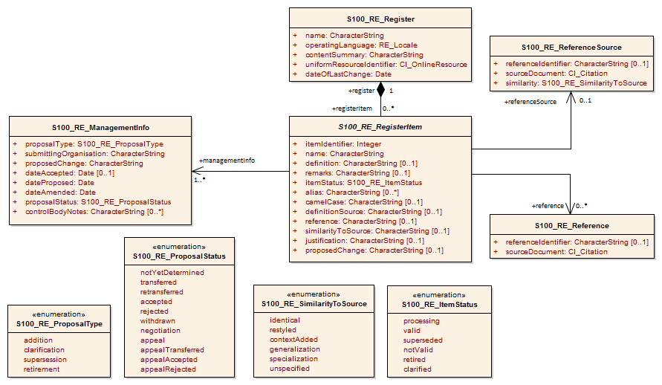

**Figure 2-3 – The Register schema**

Page intentionally left blank

## S100_RE_Register

The class S100_RE_Register specifies information about the Register itself.

|  |  |  |  |  |  |
| --- | --- | --- | --- | --- | --- |
| Role Name | Name | Description | Mult | Data Type | Remarks |
| Class | S100_RE_Register |  | - | - |  |
| Attribute | name | The name of the Register | 1 | CharacterString | Unique within the Registry |
| Attribute | operatingLanguage | The language used in this Register | 1 | RE_Locale |  |
| Attribute | contentSummary | Summary of the content | 1 | CharacterString |  |
| Attribute | uniformResourceIdentifier | The link to the interface of the Register in the Internet | 1 | CI_OnlineResource |  |
| Attribute | dateOfLastChange | The date when the last change was made to this Register | 1 | Date |  |
| Association | registerItem | The items of the Register | 0..* | S100_RE_RegisterItem |  |

## S100_RE_RegisterItem

The class S100_RE_RegisterItem carries the characteristics that are common to all types of registered items. Domain specific extensions may be added in the appropriate part of S-100; for example, Part 2a – Concept and Data Dictionary Registers.

| Role Name | Name | Description | Mult | Data Type | Remarks |
| --- | --- | --- | --- | --- | --- |
| Class | S100_RE _RegisterItem |  | - | - | Class is abstract |
| Attribute | itemIdentifier | Each item has its own unique identifier in a Register | 1 | Integer |  |
| Attribute | name | Succinct expression of the item concept it denotes | 1 | CharacterString |  |
| Attribute | definition | Shall be a precise statement of the nature, properties, scope, or essential qualities of the concept as realized by the item | 0..1 | CharacterString | Mandatory for the Concept, Data Dictionary, Portrayal and Metadata Registers |
| Attribute | remarks | Supplementary information | 0..1 | CharacterString |  |
| Attribute | itemStatus | The state in which a registered item exists | 1 | S100_RE_ItemStatus |  |
| Attribute | alias | Equivalent name(s) used for the item | 0..* | CharacterString |  |
| Attribute | camelCase | Identifier of the item using camelCase notation | 0..1 | CharacterString |  |
| Attribute | definitionSource | The source of the definition | 0..1 | CharacterString |  |
| Attribute | reference | An identifier of the place in the definitionSource from which the definition is derived | 0..1 | CharacterString |  |
| Attribute | similarityToSource | The type of change that has been made to a definition relative to the definition as it exists in the definition source | 0..1 | CharacterString |  |
| Attribute | justification | Primary reason for the proposal including how it is proposed to be used | 0..1 | CharacterString | Inherited from S-100_RE_ManagementInfo |
| Attribute | proposedChange | The text of the proposed change | 0..1 | CharacterString | Inherited from S-100_RE_ManagementInfo |
| Association | register | The Register that contains the item | 1 | S100_RE_Register |  |
| Association | referenceSource | The source information the item definition was taken from. | 0..1 | S100_RE_ReferenceSource |  |
| Association | reference | Reference to other relevant standards or documents | 0..* | S100_RE_Reference | For example INT1 or M4 |
| Association | managementInfo | Sets of information describing the management of the item in the Register | 1..* | S100_RE_ManagementInfo |  |

The camelCase must:

1. Be compound words in which the words are joined without spaces and are capitalized within the compound.
2. Be unique within the Registry.
3. Conform to UTF-8 character encoding (refer ISO/IEC 10646) with uppercase characters A-Z, lowercase characters a-z and numbers 0-9.
4. Concepts must begin with lowercase a-z.

Example 1 beaconCardinal is the Camel Case identifier for the concept Beacon Cardinal

Example 2 categoryOfLandmark is the Camel Case identifier for the concept Category of Landmark

## S100_RE_ItemStatus

The enumeration S100_RE_ItemStatus identifies the registration status of a Register item.

|  |  |  |  |
| --- | --- | --- | --- |
| Item | Name | Description | Remarks |
| Enumeration | S100_RE_ItemStaus |  |  |
| Literal | processing | The item has been entered into the Register, but the Domain Control Body is evaluating the proposal |  |
| Literal | valid | The item has been accepted, is recommended for use, and has not been superseded or retired |  |
| Literal | superseded | The item has been superseded by one or more items and is no longer recommended for use |  |
| Literal | notValid | The item has been entered into the Register, but the Domain Control Body has not accepted the proposal to add it |  |
| Literal | retired | A decision has been made that the item is no longer recommended for use. It has not been superseded by another item |  |
| Literal | clarified | The item has been clarified and is no longer recommended for use |  |

## S100_RE_ReferenceSource

The class S100_RE_ReferenceSource specifies information about the source of a Register item taken from an external document or Register.

|  |  |  |  |  |  |
| --- | --- | --- | --- | --- | --- |
| Role Name | Name | Description | Mult | Data Type | Remarks |
| Class | S100_RE_ReferenceSource |  | - | - |  |
| Attribute | referenceIdentifier | An identifier of the place in the source document that is referenced | 0..1 | CharacterString |  |
| Attribute | sourceDocument | The source document | 1 | CI_Citation |  |
| Attribute | similarity | Indicates how the definition is related to the source document | 1 | S100_RE_SimilarityToSource |  |

## S100_RE_SimilarityToSource

The enumeration S100_RE_SimilarityToSource identifies the type of change that has been made to an item specification relative to an item specification in an external source.

| Item | Name | Description | Remarks |
| --- | --- | --- | --- |
| Enumeration | S100_RE_SimilarityToSource |  |  |
| Literal | identical | No change has been made to the definition |  |
| Literal | restyled | The style of the definition has been changed to match the style and structure of other definitions in the Register that has imported the definition |  |
| Literal | contextAdded | The definition includes information about its context that is not explicit in the specification in the external source |  |
| Literal | generalization | The definition of the register item has been generalized to have a broader meaning than the item specified in the external source |  |
| Literal | specialization | The definition of the Register item has been specialized to have a narrower meaning than the item specified in the external source |  |
| Literal | unspecified | The nature of the differences between the Register item and the similar item in the external source is unspecified |  |

## S100_RE_Reference

The class S100_RE_Reference specifies information about the source and/or lineage of a specific Register item derived from an external document or Register.

| Role Name | Name | Description | Mult | Data Type | Remarks |
| --- | --- | --- | --- | --- | --- |
| Class | S100_RE_Reference |  | - | - |  |
| Attribute | referenceIdentifier | An identifier of the place in the source document that is referenced | 0..1 | CharacterString |  |
| Attribute | sourceDocument | The source document | 1 | CI_Citation |  |

## S100_RE_ManagementInfo

The class S100_RE_ManagementInfo specifies the management record of a Register item.

| Role Name | Name | Description | Mult | Data Type | Remarks |
| --- | --- | --- | --- | --- | --- |
| Class | S100_RE_ManagementInfo |  | - | - |  |
| Attribute | proposalType | The type of the proposal | 1 | S100_RE_ProposalType |  |
| Attribute | submittingOrganisation | The proposal’s sponsor | 1 | CharacterString |  |
| Attribute | proposedChange | The text describing the proposed change | 1 | CharacterString |  |
| Attribute | justification | Primary reason for the proposal including how it is proposed to be used | 1 | CharacterString |  |
| Attribute | dateAccepted | Date the proposal was accepted | 0..1 | Date |  |
| Attribute | dateProposed | Date the proposal was made | 1 | Date |  |
| Attribute | dateAmended | Date the proposal was adjudicated | 1 | Date |  |
| Attribute | proposalStatus | Provides values for describing the disposition of a proposal to add or modify a Register item | 1 | RE_ProposalStatus |  |
| Attribute | controlBodyNotes | Supplementary management information | 0..* | CharacterString |  |

## S100_RE_ProposalType

The enumeration S100_RE_ProposalType species the type of proposal for a Register item.

|  |  |  |  |
| --- | --- | --- | --- |
| Item | Name | Description | Remarks |
| Enumeration | S100_RE_ProposalType |  |  |
| Literal | addition | The item is to be added to the Register |  |
| Literal | clarification | A non-substantive change to an item in the Register |  |
| Literal | supersession | The item has been superseded by another item and is no longer recommended for use. |  |
| Literal | retirement | A decision has been made that the item is no longer recommended for use. It has not been superseded by another item |  |

## S100_RE_ProposalStatus

The enumeration S100_RE_ProposalStatus specifies the disposition of a proposal to add or change a Register item.

| Item | Name | Description | Remarks |
| --- | --- | --- | --- |
| Enumeration | S100_RE_ProposalStatus |  |  |
| Literal | notYetDetermined | The submitting Organization has submitted the proposal |  |
| Literal | transferred | The Register Manager has requested the Domain Control Body to review the proposal |  |
| Literal | retransferred | The Register Manager has requested the Submitting Organization to supplement the proposal |  |
| Literal | accepted | The Control Body has accepted the proposal |  |
| Literal | rejected | The Control Body has not accepted the proposal |  |
| Literal | withdrawn | The Submitting Organization has withdrawn the proposal |  |
| Literal | negotiation | The Domain Control Body has requested the Submitting Organization to supplement the proposal |  |
| Literal | appeal | The Submitting Organization has initiated an appeal |  |
| Literal | appealTransferred | The Register Manager has transferred the appeal to the Executive Control Body |  |
| Literal | appealAccepted | The Executive Control Body has accepted the appeal |  |
| Literal | appealRejected | The Executive Control Body has not accepted the appeal |  |